**15. ReactJS-HOL**

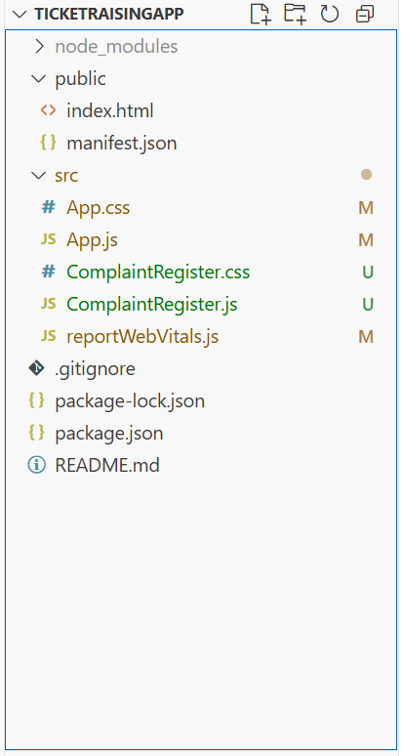

**ComplaintRegister.js**  
import React, { Component } from 'react';

class ComplaintRegister extends Component {

constructor(props) {

super(props);

this.state = {

ename: '',

complaint: '',

NumberHolder: Math.floor(Math.random() * 100) // Initial reference number

};

}

handleChange = (event) => {

this.setState({ [event.target.name]: event.target.value });

};

handleSubmit = (event) => {

event.preventDefault();

const refNo = Math.floor(Math.random() * 1000);

this.setState({ NumberHolder: refNo });

const msg = `Thanks ${this.state.ename}\nYour Complaint was Submitted.\nTransaction ID is: ${refNo}`;

alert(msg);

};

render() {

return (

<div>

<label>Name: </label>

<input

type="text"

name="ename"

value={this.state.ename}

onChange={this.handleChange}

required

/>

</div>

<br />

<div>

<label>Complaint: </label>

<textarea

name="complaint"

value={this.state.complaint}

onChange={this.handleChange}

required

/>

</div>

<br />

<button type="submit">Submit</button>

</form>

</div>

);

}

}

export default ComplaintRegister;

**App.js**

import React from 'react';

import ComplaintRegister from './ComplaintRegister';

function App() {

return (

<div className="App">

<ComplaintRegister />

</div>

);

}

export default App;

